**7. BLYNK IOT APPLICATION**

**7.1 BLYNK QUICK START**

Let’s start right away. First, you only need a microcontroller board. The most useful is one with integrated WiFi, such as an ESP32, ESP8266 / Wemos, Arduino MKR1010 or Arduino Nano 33IoT. Navigate to the [Blynk website](https://blynk.io/" \t "_blank), click on “Start free” and create an account. Languages available are English, German and Russian.

[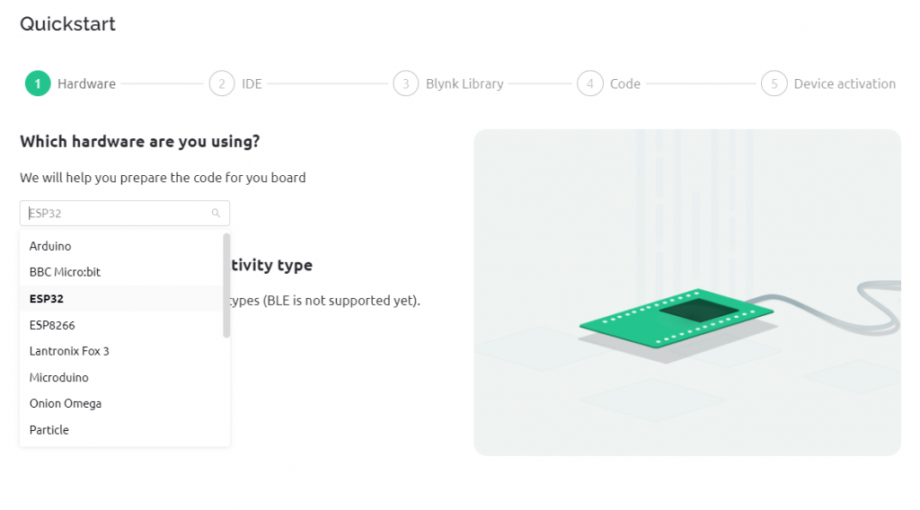](https://wolles-elektronikkiste.de/wp-content/uploads/2022/01/01_quickstart_engl.png)

Blynk Quick Start, Step 1

Now you choose your development environment (IDE):

[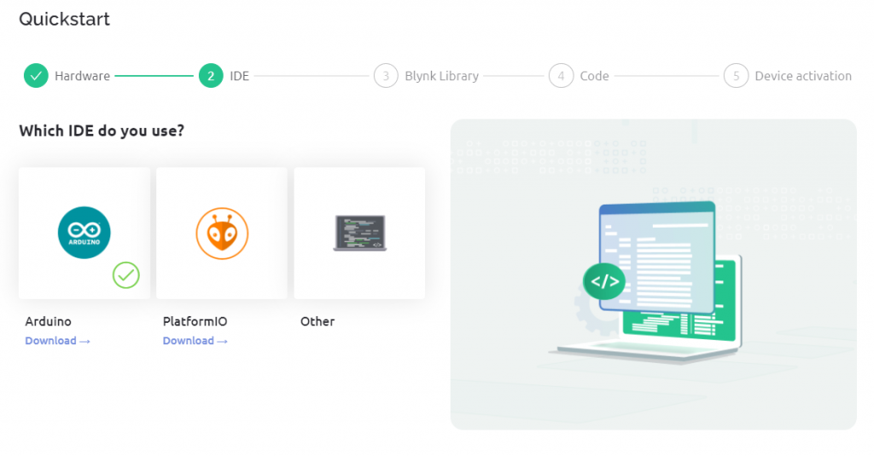](https://wolles-elektronikkiste.de/wp-content/uploads/2022/01/02_quickstart_engl.png)

Blynk Quick Start, Step 2

Install the Blynk library:

[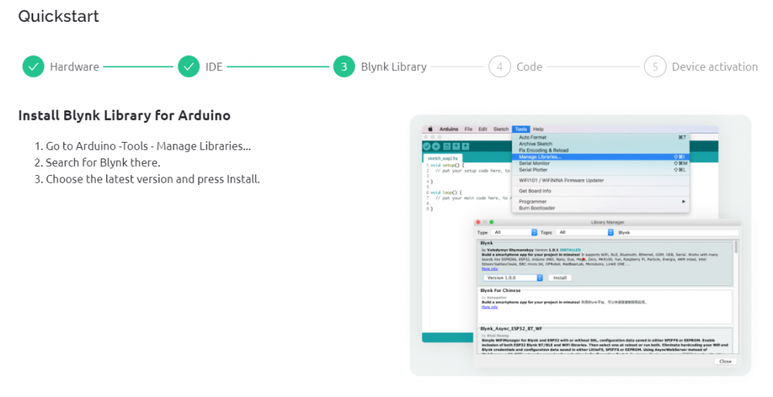](https://wolles-elektronikkiste.de/wp-content/uploads/2022/01/03_quickstart_engl.png)

Blynk Quick Start, Step 3

Enter your Wi-Fi credentials. These are transferred directly to the quick start sketch and are not stored on Blynk. If you don’t trust the system, you can also insert the access data manually later into the sketch. You can download the sketch or copy the code. Then upload the sketch to your board.

[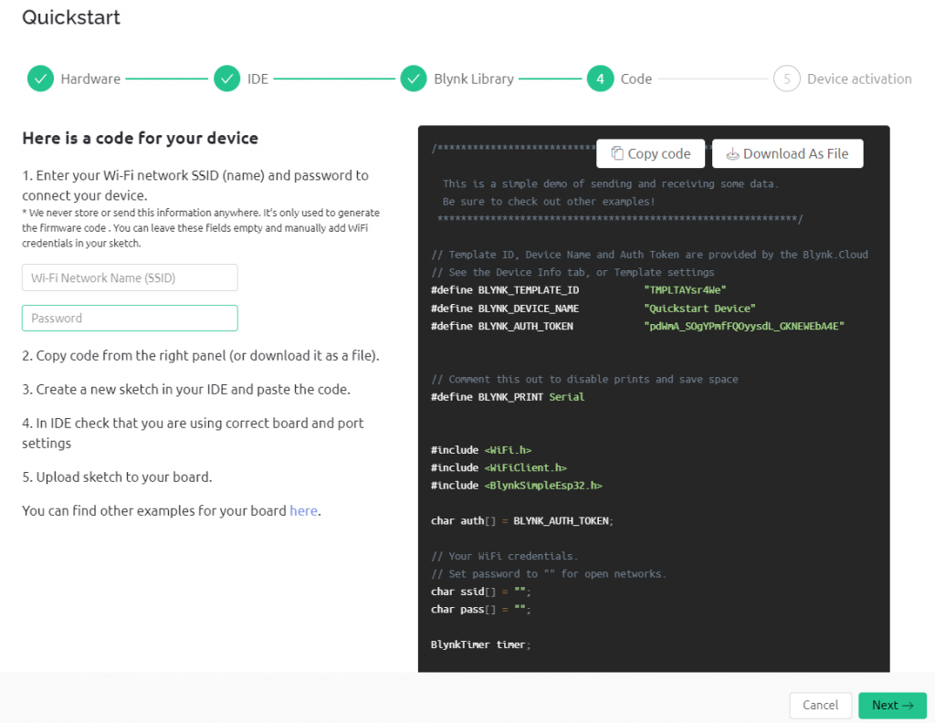](https://wolles-elektronikkiste.de/wp-content/uploads/2022/01/04_quickstart_engl.png)

Blynk Quick Start, Step 4

If everything worked out, your board is now online and you will be rewarded with a shower of confetti:

[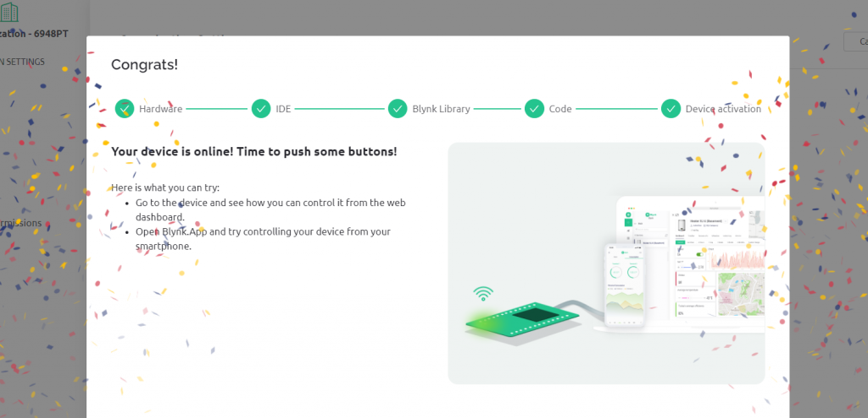](https://wolles-elektronikkiste.de/wp-content/uploads/2022/01/05_quickstart_engl.png)

Blynk Quick Start, Step 5

The window you’re in is the Blynk console. Use the magnifying glass icon to navigate to your board, which Blynk has created under the name “Quickstart Device”. There you will find the pre-installed widgets in the dashboard. The Dashboard is your control center from which you steer your microcontroller and display values. Widgets are functions that you can select, such as displays, switches, sliders or charts.

[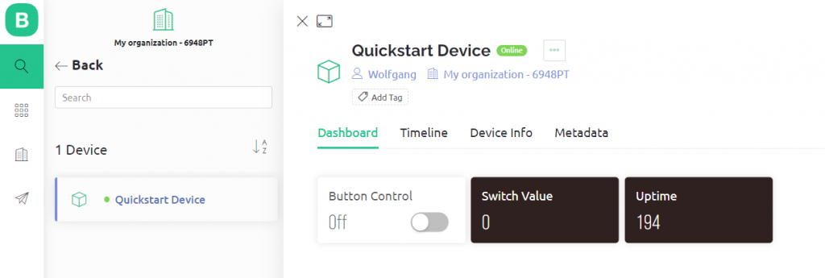](https://wolles-elektronikkiste.de/wp-content/uploads/2022/01/06_gotoDevice_engl.png)Blynk Quickstart Dashboard

**7.2 NEW DEVICE**

There are several ways to create new devices. I find the following the easiest. Go to the devices (magnifying glass icon) and click on “New Device”.

[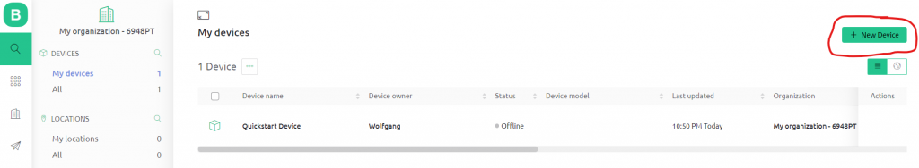](https://wolles-elektronikkiste.de/wp-content/uploads/2022/01/11_new_device_engl.png)

Select “From template”:

[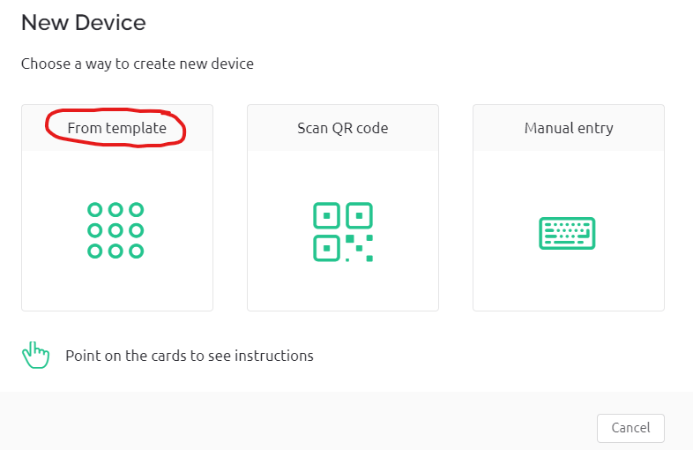](https://wolles-elektronikkiste.de/wp-content/uploads/2022/01/12_new_device_from_template_engl.png)

Enter the template you want to use and click on “Create”:

[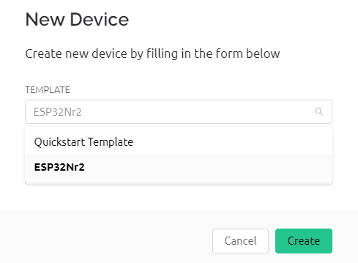](https://wolles-elektronikkiste.de/wp-content/uploads/2022/01/13_new_device_create_engl.png)

The new device is created. On the right side you can see the template ID, the device name and the authentication token. You can easily copy this data to the clipboard and paste it into your sketch.

[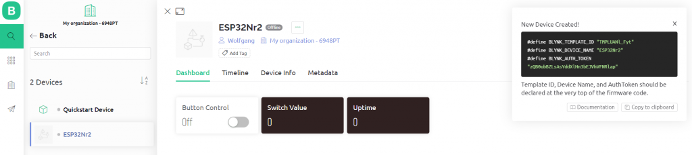](https://wolles-elektronikkiste.de/wp-content/uploads/2022/01/14_new_device_created_engl.png)

There is still the question of where to get the sketch for the new device. There are several options:

* You take an existing Blynk sketch and copy the template ID, device name and token into it. If you change your board (from ESP32 to ESP8266, for example), then you have to make further adjustments. In this case, I would recommend one of the next two options.
* Uses the “Blynk Example Browser”, here is the [link](https://examples.blynk.cc/?board=ESP8266&shield=ESP8266%20WiFi&example=GettingStarted%2FBlynkBlink).
* You run through the quick start process again, but cancel it after the code creation and copy template ID, device name and token into it.
* Once you have created and adapted the sketch, you upload it to your microcontroller board. It should now appear in the device list.
* Adding widgets
* So far, we have been content with switching the LED and transmitting the system time. That’s still a bit boring. In the next step, we’ll add two more widgets:
* With a slider, the brightness of an LED is to be controlled remotely using PWM.
* The measured values of a sensor shall be output on the dashboard and displayed graphically. As a substitute for a sensor value, I take the voltage of a connected potentiometer.

**7.3 CORRESPONDING SIMPLE CIRCUIT:**

[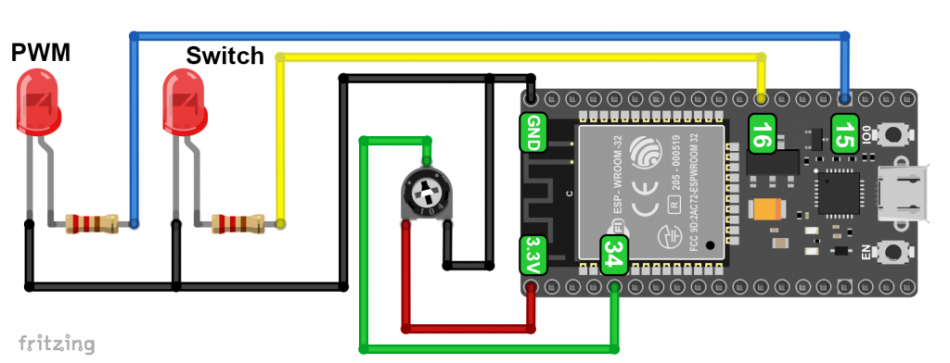](https://wolles-elektronikkiste.de/wp-content/uploads/2022/01/ESP32_wiring.png)Example circuit

**7.4 CREATING DATA STREAMS / VIRTUAL PINS**

Since we want to transmit additional data, we must first define the corresponding data streams. To do this, go to the templates in the Blynk console, select the template to be changed, go to the tab “Data streams” and then “Edit”. Select New Datastream, and then select Virtual Pin.

I named the data stream for reading the voltage “VoltRead” and assigned it the virtual pin V4. The data type is a floating-point number, and “double” is available for this. For the units, I could have put volts, but I just forgot and was too lazy to repeat everything. The minimum is 0 volts, the maximum 3.3 volts. Then you can choose how many decimal places you want to use. The default value is the start value if there is no measured data yet. When you have entered everything, click on “Create”.

[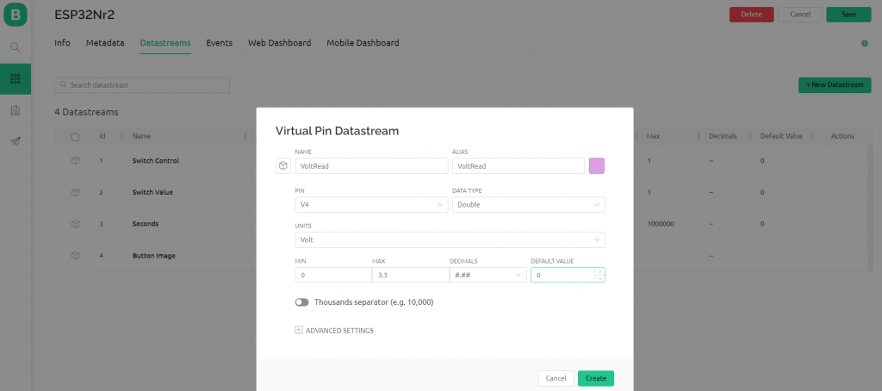](https://wolles-elektronikkiste.de/wp-content/uploads/2022/01/15_new_datastream_engl.png)Data stream settings

For the PWM control you proceed similarly. I named the data stream “PWM Value”. Since I set the PWM resolution in the sketch to 10 bits, the min/max range is from 0 to 1024. “PWM Value” is an integer:

[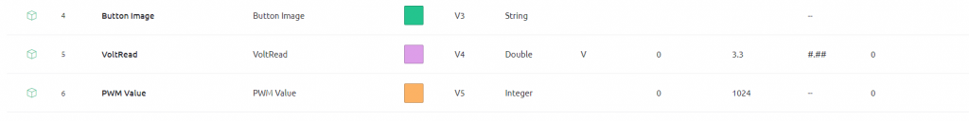](https://wolles-elektronikkiste.de/wp-content/uploads/2022/01/16_new_datastream_engl.png)Additional data streams

**7.5 AUTOMATIONS AND NOTIFICATIONS WITH BLYNK**

So far, we have only read data or transmitted data to control things. Now it gets a bit more exciting with automation. Typical examples from home automation would be:

* If the daylight is less than x, close the blinds.
* Turn a lamp on and off at a certain time.
* Notify me when the motion detector is triggered.

Here are two simple examples using my circuit above that you can easily transfer to other applications:

* Turn the LED on and off at specific times.
* If the voltage exceeds 2.2 volts, send me a notification on my smartphone.

First, you need to expose the data streams to automation. To do this, go to your template → Data streams → Edit → Data stream / Virtual pin to be edited. In my example, the affected data streams or virtual pins are V0 and V4. Enable “Advanced Settings” and make your adjustments:

[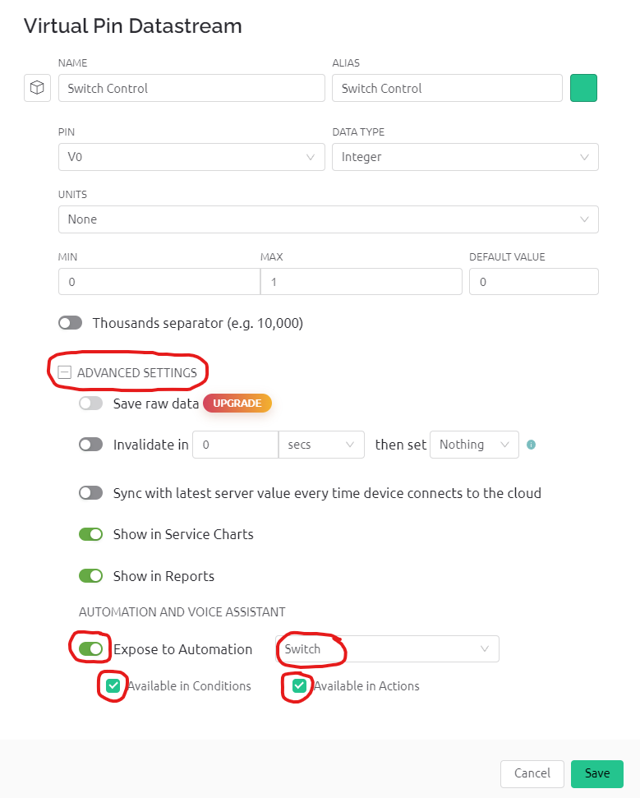](https://wolles-elektronikkiste.de/wp-content/uploads/2022/01/22_led_automate_engl.png)

Enable Automation (Switch)

[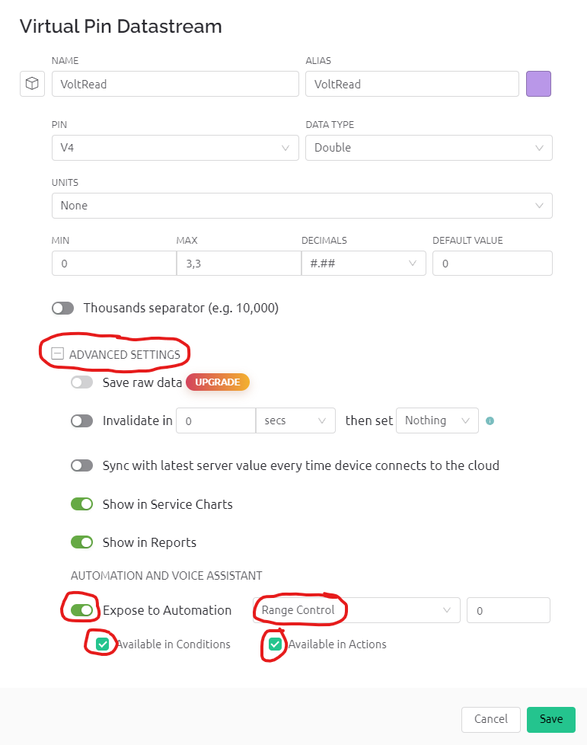](https://wolles-elektronikkiste.de/wp-content/uploads/2022/01/22_vref_notify_engl.png)

Enable automation (VoltRead)

Now go to the Automations section via the menu and select “Add Automation”. To switch on the LED, select the option “Schedule”:

[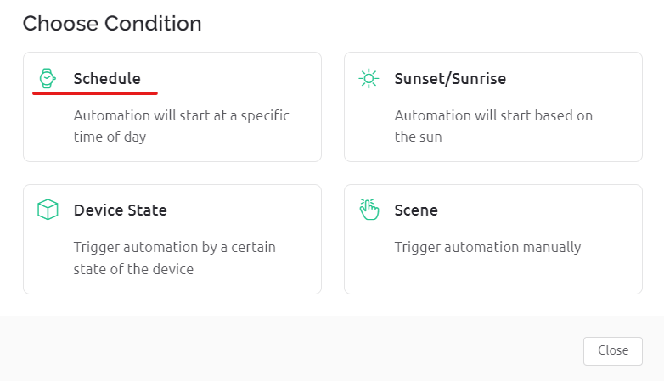](https://wolles-elektronikkiste.de/wp-content/uploads/2022/01/23_led_auto_engl.png)

In the next window, you then make settings of your choice:

[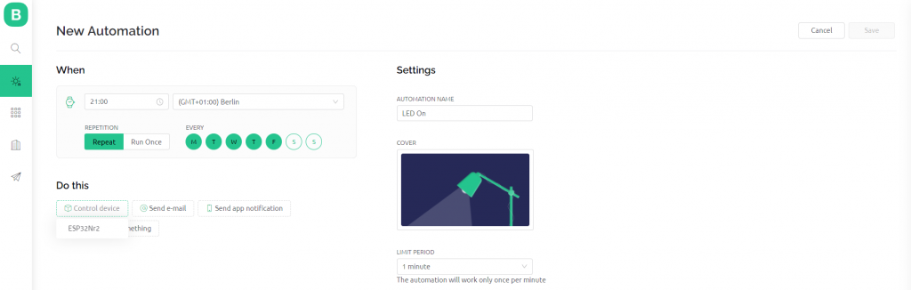](https://wolles-elektronikkiste.de/wp-content/uploads/2022/01/24_led_auto_engl.png)

After you have selected the control device (i.e. your microcontroller board), you still have to specify the data stream. To activate, you must set the switch symbol behind Switch Control to “On”:

[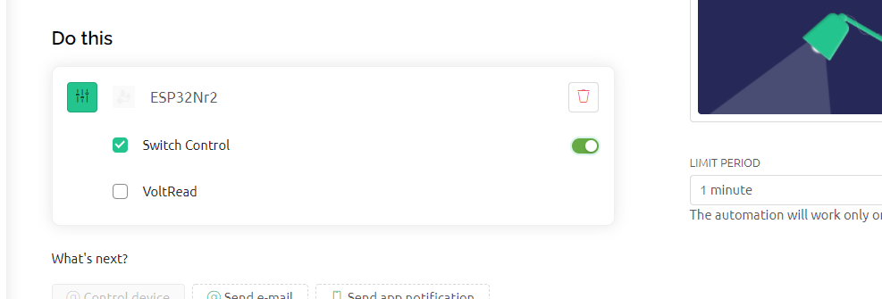](https://wolles-elektronikkiste.de/wp-content/uploads/2022/01/25_led_auto_engl.png)

For the automated switch-off, repeat the whole procedure accordingly.

To activate the notification, proceed similarly, but select the option “Device status” in the “Choose condition” window. The other settings are also self-explanatory again. A prerequisite for receiving the message is, of course, that you have stored your phone number in the settings.

[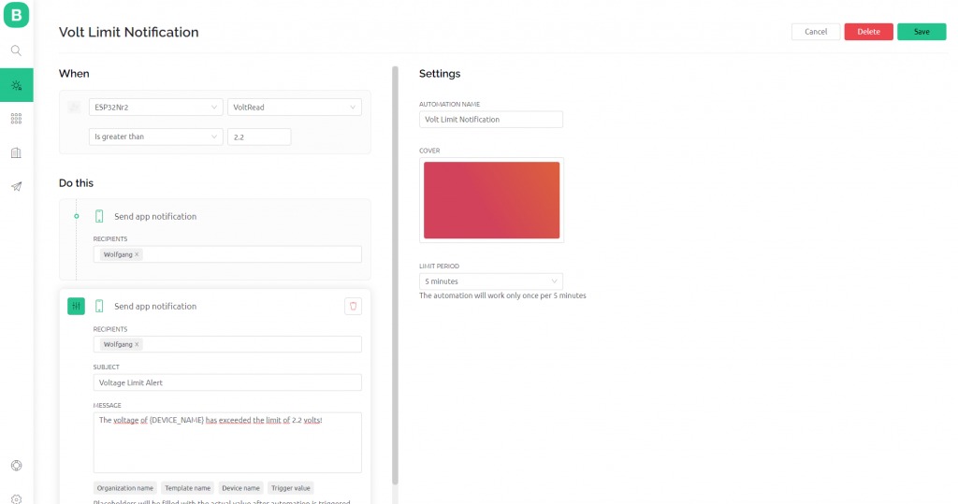](https://wolles-elektronikkiste.de/wp-content/uploads/2022/01/26_volt_notification_engl.png)

This is what the overview of automations looks like:

[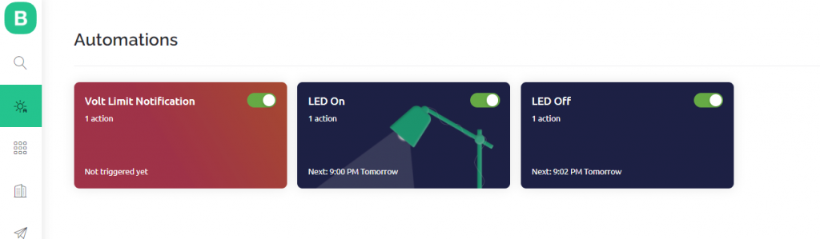](https://wolles-elektronikkiste.de/wp-content/uploads/2022/01/27_all_automations_engl.png)

And finally, the notification on the smartphone:

[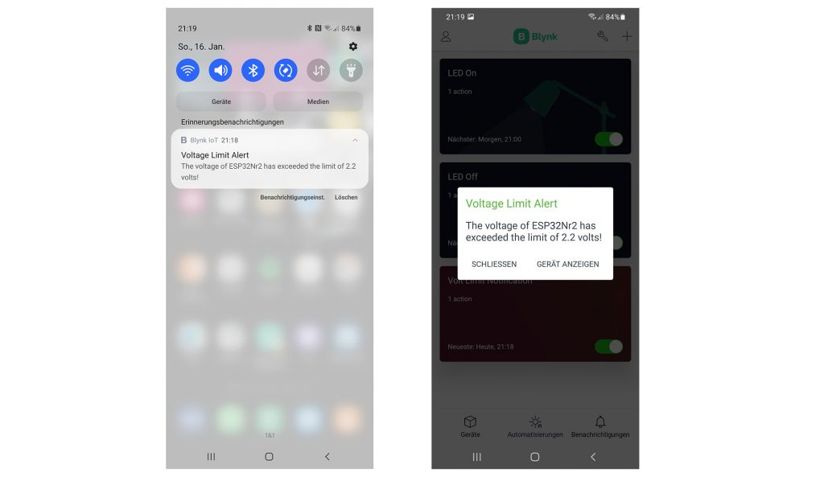](https://wolles-elektronikkiste.de/wp-content/uploads/2022/01/voltage_warning.jpg)

Blynk Notifications